|  |  |  |  |  |  |  |  |  |  |  |
| --- | --- | --- | --- | --- | --- | --- | --- | --- | --- | --- |
| **WEEKLY REPORT** | | | | | | | | | | |
|  |  |  |  |  |  |  | |  |  |  |
| **TIME:** | From |  | Feb 14 2023 | To |  | Feb 26 2023 | |  |  |  |
|  |  |  |  |  |  |  | |  |  |  |
| **TEAM:** SCEM SOFTWARE DEVELOPER | | | | | | |  | | |  |
|  |  |  |  |  |  |  | |  |  |  |
| **TEAM LEADER:** BENJAMIN **(**NHAT MINH NGUYEN**) –** FREELANCER SOFTWARE DEVELOPER | | | | | | |  | | |  |
|  |  |  |  |  |  |  | |  |  |  |
| **PRODUCT MANAGER:** PHAN, HUY VINH | | | | | | |  | | |  |
|  |  |  |  |  |  |  | |  |  |  |
| **CHECK BY**: HOAI NAM DANG, ANNA TRAN | | | |  |  |  | |  |  |  |

1. **DETAIL**

* Software development of the SCEM project based on a detailed design of functions.

<https://github.com/shp2018/SCEM/>

1. **TIME SHEET**

<https://docs.google.com/spreadsheets/d/1F1uyCEODLtAdosbROM_09gjq7IPNbW-k6J0CBjLqVFo/edit?usp=sharing>

1. **COMPLETED**

* Graphical user interface

  Description automatically generatedLogin Screen + Sign in with Google/Facebook function
* Graphical user interface, application

  Description automatically generatedSignup Screen
* Graphical user interface

  Description automatically generatedForgot Password Screen and Function

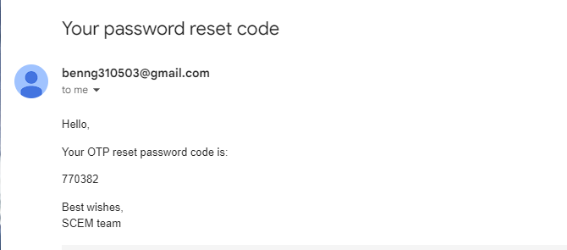

1. **PLANNING**

<https://github.com/shp2018/SCEM/issues>

**2/27 – 3/5:**

* Integrate database into project to store user data.
* Finish development of Reset Password page and functionality.
* Finish development of functions that interact with user data.

**If time permits:**

* Begin development of Home and Marketplace page (pg 24-26 in project detail document).